*Create Table Salesman, Customer, Order*

*Sample table*: salesman

salesman_id name city commission

----------- ---------- ---------- ----------

5001 James Hoog New York 0.15

5002 Nail Knite Paris 0.13

5005 Pit Alex London 0.11

5006 Mc Lyon Paris 0.14

5003 Lauson Hen 0.12

5007 Paul Adam Rome 0.13

*Sample table*: customer

customer_id cust_name city grade salesman_id

----------- ------------ ---------- ---------- -----------

3002 Nick Rimando New York 100 5001

3005 Graham Zusi California 200 5002

3001 Brad Guzan London 5005

3004 Fabian Johns Paris 300 5006

3007 Brad Davis New York 200 5001

3009 Geoff Camero Berlin 100 5003

3008 Julian Green London 300 5002

3003 Jozy Altidor Moscow 200 5007

*Sample table*: orders

ord_no purch_amt ord_date customer_id salesman_id

---------- ---------- ---------- ----------- -----------

70001 150.5 2012-10-05 3005 5002

70009 270.65 2012-09-10 3001 5005

70002 65.26 2012-10-05 3002 5001

70004 110.5 2012-08-17 3009 5003

70007 948.5 2012-09-10 3005 5002

70005 2400.6 2012-07-27 3007 5001

70008 5760 2012-09-10 3002 5001

70010 1983.43 2012-10-10 3004 5006

70003 2480.4 2012-10-10 3009 5003

70012 250.45 2012-06-27 3008 5002

70011 75.29 2012-08-17 3003 5007

70013 3045.6 2012-04-25 3002 5001

**Write a query to find those customers with their name and those salesmen with their name and city who lives in the same city.**

**Sample Solution:**

SELECT customer.cust_name,

salesman.name, salesman.city

FROM salesman, customer

WHERE salesman.city = customer.city;

**Output of the query:**

cust_name name city

Nick Rimando James Hoog New York

Brad Davis James Hoog New York

Julian Green Pit Alex London

Fabian Johnson Mc Lyon Paris

Fabian Johnson Nail Knite Paris

Brad Guzan Pit Alex London

**Explanation:**

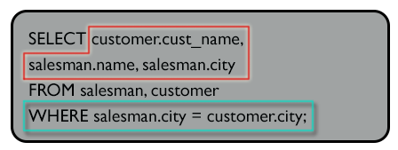

**Pictorial presentation:**

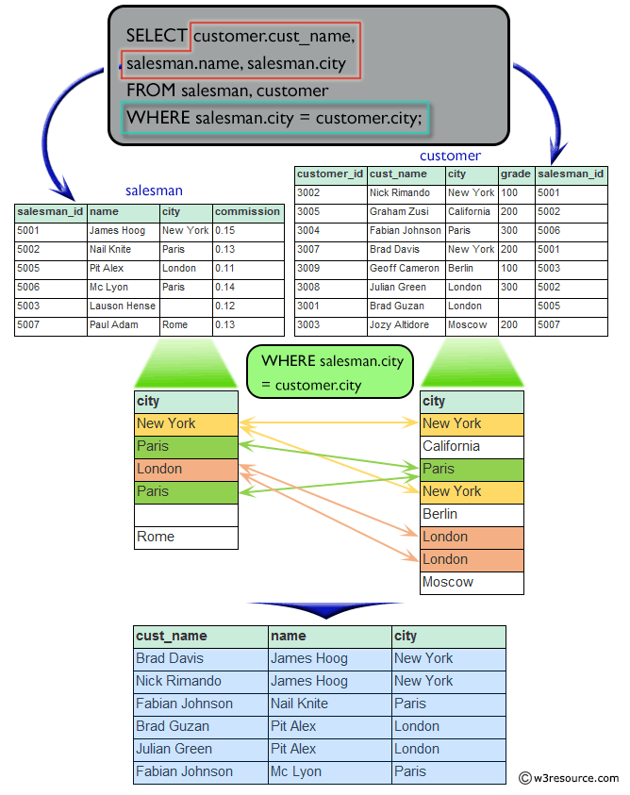  
**Write a SQL statement to find the names of all customers along with the salesmen who works for them.**

Logipool Infotech

**Sample Solution:**

SELECT customer.cust_name, salesman.name

FROM customer,salesman

WHERE salesman.salesman_id = customer.salesman_id;

**Output of the query:**

cust_name name

Nick Rimando James Hoog

Brad Davis James Hoog

Graham Zusi Nail Knite

Julian Green Nail Knite

Fabian Johnson Mc Lyon

Geoff Cameron Lauson Hen

Jozy Altidor Paul Adam

Brad Guzan Pit Alex

**Explanation:**

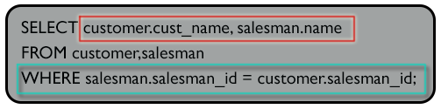

**Write a SQL statement to display all those orders by the customers not located in the same cities where their salesmen live.**

**Sample Solution:**

SELECT ord_no, cust_name, orders.customer_id, orders.salesman_id

FROM salesman, customer, orders

WHERE customer.city <> salesman.city

AND orders.customer_id = customer.customer_id

AND orders.salesman_id = salesman.salesman_id;

**Output of the query:**

ord_no cust_name customer_id salesman_id

70004 Geoff Cameron 3009 5003

70003 Geoff Cameron 3009 5003

70011 Jozy Altidor 3003 5007

70001 Graham Zusi 3005 5002

70007 Graham Zusi 3005 5002

70012 Julian Green 3008 5002

**Explanation:**

